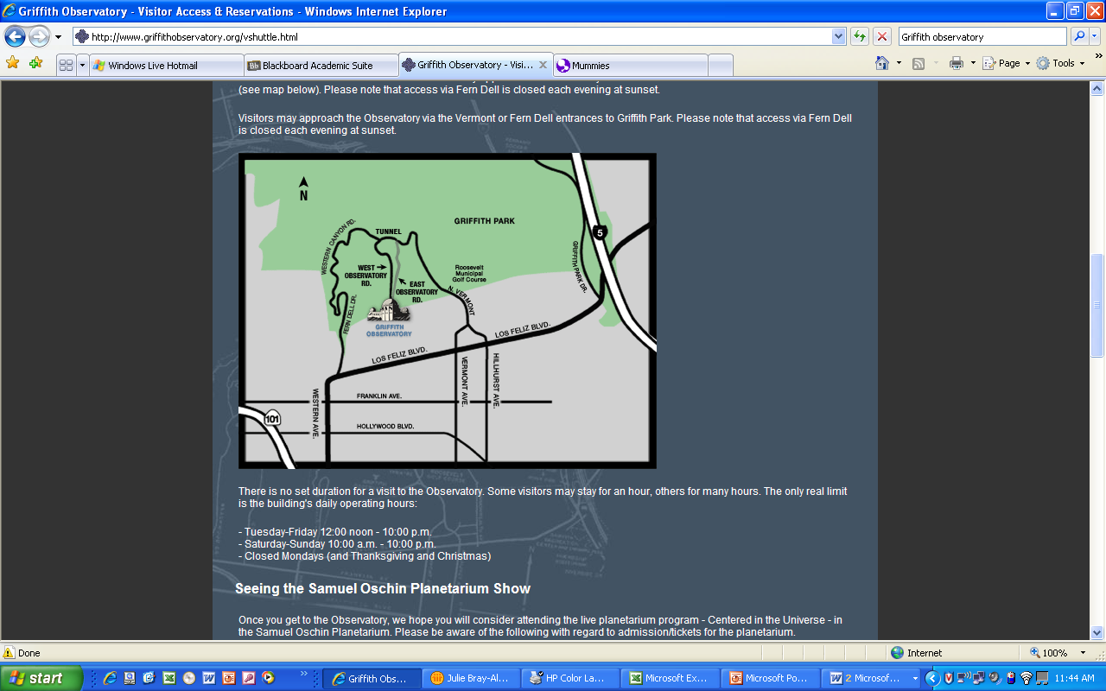***Astronomy field trip:* Griffith Observatory**.

The Alternative field trip is to go to the Griffith observatory (http://www.griffithobs.org/; directions at right; floor plan below). VISIT WEBSITE for parking instructions and hours of operation!!! If this is your option, see below* for the instructions on your written report. Be prepared to watch any one of the planetarium shows, and to study the exhibits. If you are there after sunset, look through their telescope on the roof (instead of looking at the Sun – Hall of the Sky question)!



* After your visit, turn in your TYPED answers to the questions below, and write a one page report on your experience based on those questions. (Everything you turn in should be typed and double-spaced.) Please attach your planetarium ticket, a **picture of yourself**, and other items, as explained below!! This packet may certainly be e-mailed to me by the due date.

Speaking of Due Date, the completed report is due to me by THE STARTING MOMENT OF YOUR Final Exam. Never forget that you may email your report before the due date/time, by attaching it as a pdf or doc file …

**Griffith Observatory report** Name: ________________

***Hall of the Sky*** :

A. Comment in your own words what you saw in this display. [If you visited during the daytime] did you find any current sunspots? Draw a picture of the sun on the day of your visit (look through the solar telescope)! [If you visited after sunset] What did you see using the rooftop telescope?

***Hall of the Eye***:

A. Find the oldest telescope they have on display and write about it in your own words.

B. Look at the infrared camera. Which color represent hotter / cooler? Which part of your face is lower in temperature, and why do you suppose that is?

[***Gunther Depths of Space***](http://www.griffithobservatory.org/exhibits/bdepthsofspace.html)

A. Go to the exhibit called A Familiar Star Pattern. Write about what you learned. What is the arrangement of the stars called?

B. Next to the “Earth” you will find a seismograph. Make an earthquake, take a picture of your seismogram and attach it to the report. How did you make the earthquake?

C. Take a picture of you with Einstein. Explain what he is doing.

***Outside***

A. Find the sundial. Take a picture and attach it. Read the sundial. Was it accurate?

B. Find meridian line. Where was it? Explain how it works.

***Planetarium show***: (VISIT WEBSITE to find appropriate show at a convenient time – if you have a student ID you can get a discount!)

A. Which show did you see, and what did you learn from the planetarium show?

***On Your Own***:

Write about three other things you thought were interesting (and astronomical).

** Please remember to **attach the following to your report**: **

1. A picture you drew of the Sun as you saw it
2. A picture of your seismogram
3. A picture of yourself ***posing with Einstein***
4. A picture of the Sundial
5. Your planetarium ticket