C:\Users\mcooper\AppData\Local\Microsoft\Windows\Temporary Internet Files\Content.IE5\G1SVWFM7\MC900358169[1].wmf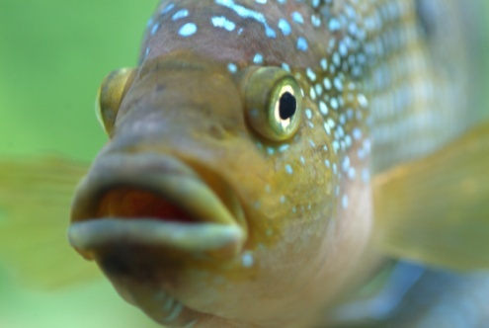

Biology 2

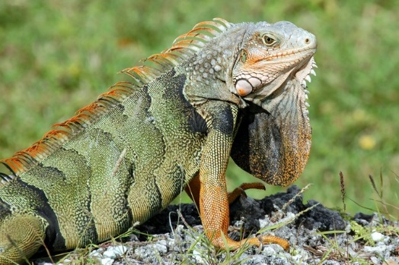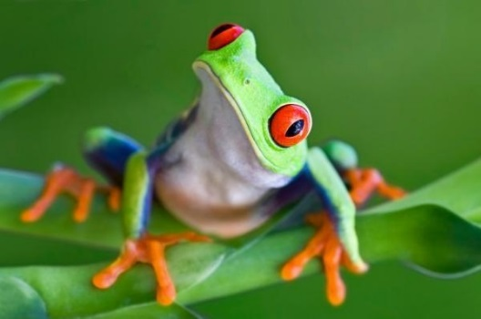

Lab Packet

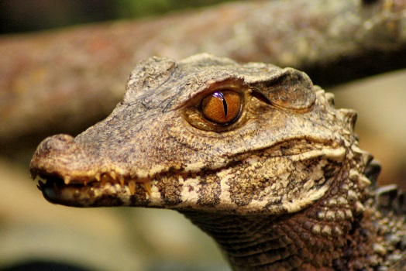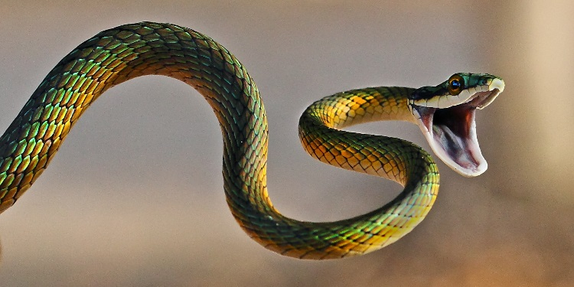For

Practical 4

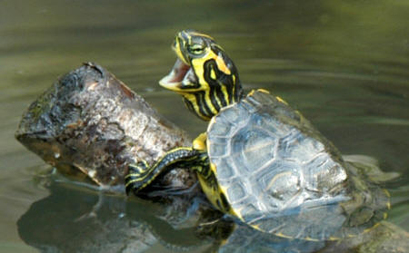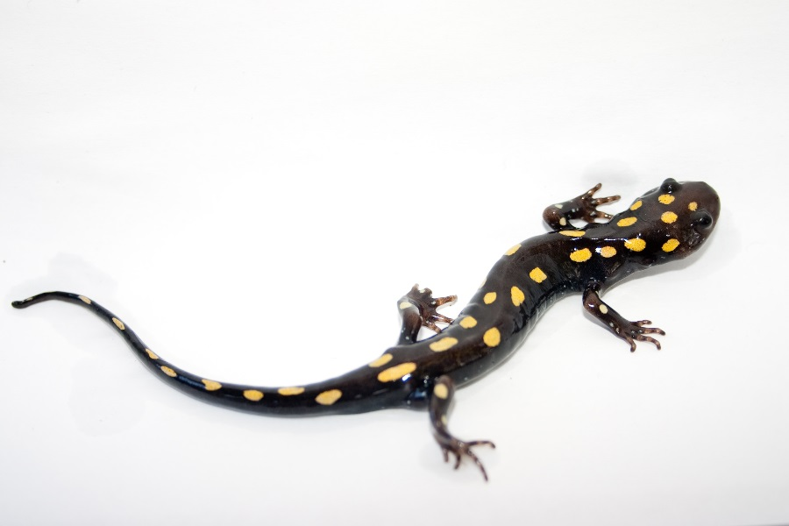

**CLASSIFICATION:**

**Domain: Eukarya Supergroup: Unikonta Clade: Opisthokonts Kingdom: Animalia**

**Phylum: Chordata – Chordates**

Subphylum: Urochordata - Tunicates

Subphylum: Cephalochordata - Lancelets

Subphylum: Vertebrata – Vertebrates

Superclass: Agnatha

Order: Myxiniformes – Hagfish

Order: Petromyzontiformes – Lamprey

Superclass: Gnathostomata – Jawed Vertebrates

Class: Chondrichthyes - Cartilaginous Fish

Subclass: Elasmobranchii – Sharks, Skates and Rays

Order: Lamniiformes – Great White Sharks

Order: Carcharhiniformes – Ground Sharks

Order: Orectolobiniformes – Whale Sharks

Order: Rajiiformes – Skates

Order: Myliobatiformes - Rays

Subclass: Holocephali – Ratfish

Order: Chimaeriformes - Chimaeras

Class: Sarcopterygii – Lobe-finned fish

Subclass: Actinistia - Coelocanths

Subclass: Dipnoi – Lungfish

Class: Actinopterygii – Ray-finned Fish

Order: Acipenseriformes – Sturgeon, Paddlefish

Infraclass: Holostei

Order: Lepisoteriformes - Gars

Order: Amiiformes – Bowfin

Infraclass: Teleostei

Superorder: Osteoglossomorpha

Order: Osteoglossiformes – Arowana, Elephant fish

Superorder: Elopomorpha

Order: Anguilliformes - Morey eels

Superorder: Clupeiformorpha

Order: Clupeiformes - Ancovies, Sardines

Superorder: Ostariphysi

Order: Cypriniformes – Carp, Minnows

Order: Characiformes – Piranha

Order: Siluriformes – Catfish

Order: Gymnotiformes - Knifefish

Superorder: Protacanthopterygii

Order: Salmoniformes – Salmon, Trout

Order: Esociformes - Pike

Superorder: Stomiatii

Order: Osmeriformes – Smelt

Order: Stomiiformes – Dragonfish, Hatchetfish

Superorder: Scopelomorpha

Order: Myctophiformes – Lantern Fish

Superorder: Acanthopterygii

Order: Mugiligormes - Mullet

Order: Atheriniformes – Grunion, Silversides

Order: Beloniformes - Flying Fish

Order: Cyprinodontiformes –Pupfish, Mosquitofish

Order: Stephanoberyciformes - Ridgehead

Order: Gobiesociformes – Clingfish

Order: Synganthiformes - Sea Horses, Pipefish

Order: Tetradontiformes – Porcupine fish Order: Pleuronectiformes - Halibut

Order: Scorpaeniformes - Sculpin

Order: Perciformes – 40% of fish

Class: Amphibia – Amphibians

Order: Urodela - Salamanders

Order: Apodans - Caecilians

Order: Anurans – Frogs/Toads

Class: Testudines – Turtles

Class: Sphenodontia – Tuataras

Class: Squamata – Lizards/Snakes

Lizards

Family – Agamidae – Old World Lizards

Family – Anguidae – Glass Lizards

Family – Chameleonidae – Chameleons

Family – Corytophanidae – Helmet Lizards

Family - Crotaphytidae – Collared Lizards

Family – Helodermatidae – Gila monster

Family – Iguanidae – Iguanids

Family – Phrynosomatidae – NA Spiny Lizards

Family – Polychrotidae – Anoles

Family – Geckonidae – Geckos

Family – Scincidae – Skinks

Family – Anniellidae – Legless Lizards

Family – Teiidae – Whiptail Lizards

Snakes

Family – Boidae – Boas

Family – Pythonidae - Pythons

Family – Colubridae – Colubrids

Family – Elapidae – Elapids

Family - Viparidae - Viperids

Class: Crocodilia – Crocodilians

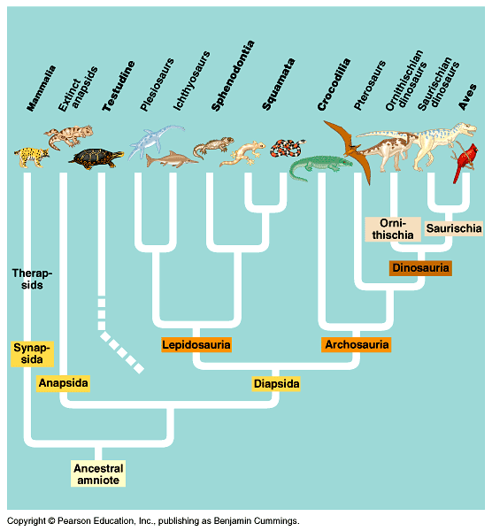

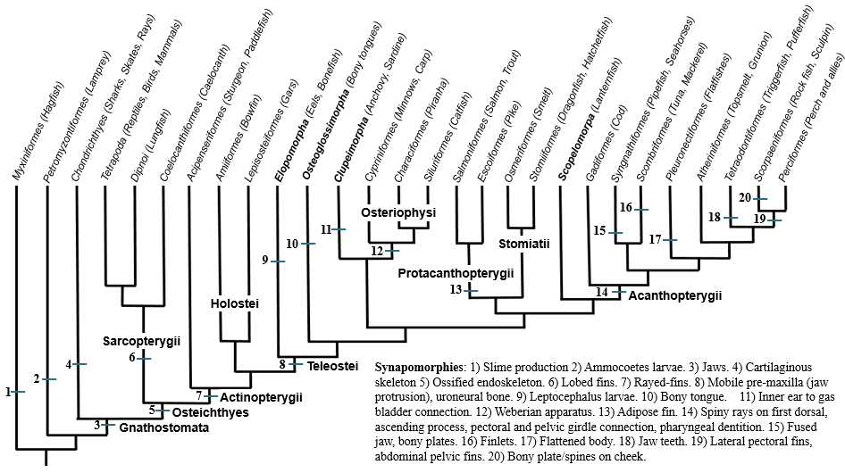

**Introduction – Phylum Chordata**

Although chordates vary widely in appearance, they are distinguished as a phylum by the presence of four anatomical features that appear sometime during their life time. They exhibit deuterostome development and bilateral symmetry. Chordates only comprise 5% of the animal species but may be the most commonly known phylum. They comprise of both invertebrates and vertebrates.

**Station 1 – Phylum: Chordata**

1. What four characteristics are shared by all chordates and what are their functions?
2. What are the three subphyla included in this phylum?
3. When did chordates appear in the fossil record?

**Station 2 – Subphylum: Urochordata.** Be able to recognize the examples at this station.

### 1. What are the chordate characteristics found in the adults in this subphylum?

2. What are they considered the closet relative to?

3. What habitat are tunicates found in?

4. What king of diet do tunicates have?

**Station 3 – Subphylum: Cephalochordata.** Be able to recognize the examples at this station.

### 1. What are the chordate characteristics found in the adults in this subphylum?

2. What is unique about the way lancelets breath?

3. Where are lancelets found geographically? What habitat are lancelets found it?

4. What type of diet do lancelets have?

**Station 4 - Subphylum: Vertebrata**

### What are the chordate characteristics found in the adults in this subphylum?

### What type of lifestyle do they demonstrate?

3. When did vertebrates diverge from other chordates?

**Station 5 – Fish**

### What is a “fish”?

1. What are the four major groups of fish?

**Station 6 – Fish Scales** Be able to recognize the examples at this station.

1. What are the four types of fish scales, and what groups typically have each kind of scale?

2. How do fish scales differ from reptile scales?

**Station 7 – Fish Reproductive Strategies** Be able to recognize the examples at this station.

1. What are the four types of reproductive strategies found in fish? Know the definition of each.

**Station 8 - Superclass: Agnatha – Hagfish** Be able to recognize the examples given at this station.

1. What do all fish in this superclass lack?

2. How do hagfish differ from lampreys?

3. What do hagfish produce?

4. What can they do to their bodies and what is the function of this behavior?

5. Where are hagfish found geographically? What habitat are they found in?

6. What type of feeding behavior is found in the hagfish? How do they find their prey?

**Station 9 - Superclass: Agnatha – Lamprey** Be able to recognize the examples given at this station.

1. What are lamprey larvae called? Where are they found and how do they obtain food?
2. What happens to the lamprey larvae when going through metamorphosis?
3. Where do they typically live and where do they spawn? What is this term for this type of lifestyle?
4. What type of feeding behavior is found in some adult lamprey species? How does this differ from the feeding strategy of the lamprey larvae?

**Station 10 – Superclass: Gnathostomata**

### 1. What characteristic do the organisms within this superclass have?

3. What did the jaws likely develop from?

3. What did the development of jaws allow for? How was this significant to vertebrate evolution?

**Station 11 – Class: Chondrichthyes.** Be able to recognize the examples at this station.

1. What is the chondrichthyan skeleton made of? Is this a primitive characteristic?

2. What other characteristics are found in chondrichthyans?

3. What is the name of the specialized sensory organ found in many chondrichthyans? What does is sense?

4. How do you tell the difference between males from female chondrichthyans?

5. What are the two subclasses found in this class? What are their characteristics?

**Station 12 – Sharks**

Be able to recognize the examples at this station and know their characteristics.

**Order Lamniformes – Great white shark**

1. How big do great whites get?
2. What type of reproduction do great white sharks have?
3. In the last 100 years, more people have been killed in the U.S. by what animal over this shark?
4. Where are they geographically found? What is the name of the zone where enough light penetrates to sustain photosynthesis?
5. What type of diet do they have?

**Order Carcharhiniformes - Hammerhead shark**

1. How big do hammerhead sharks get?
2. What type of reproduction do hammerhead sharks have?
3. What does the hammer head do for the animal and how many more times effective is it than other sharks?
4. Where are they geographically found?
5. What type of diet do they have?

**Order Carcharhiniformes - Leopard shark**

1. How big do leopard sharks get?

2. How do they differ from their close relatives? How might this benefit leopard sharks?

3. Where are they geographically found? What habitat are they typically found in?

4. What type of diet do they have?

**Order Orectolobiniformes – Whale shark**

1. How big do whale sharks get?

2. What type of reproductive strategy do whale sharks have?

3. How much water can they filter in an hour?

4. Where are they geographically found?

1. What type of diet do they have?

**Station 13 – Orders: Rajiformes and Myliobatiformes: Skates and Rays**

Fill out the following table – Be able to recognize the pictures and/or specimens of these organisms.

|  |  |  |
| --- | --- | --- |
| **Characteristic** | **Skate** | **Ray** |
| **Caudal Fin** |  |  |
| **Stinging Spines** |  |  |
| **Pelvic Fins** |  |  |
| **Reproduction** |  |  |

**Station 14 – Order Rajiformes – Skates** Be able to recognize the examples at this station

**Big skate**

1. How big do big skates get?

2. What type of reproduction do they have? What are their eggs often called?

3. Where are skates geographically found? What type of habitat are they found in?

4. What type of diet do skates have?

**Shovelnose guitarfish**

1. What adaptation do skates and rays have that allows them to breathe while buried in the sand?

2. How are guitarfish different from other rays?

2. Where are guitarfish geographically found? What type of habitat are they found in?

3. What type of diet do guitarfish have?

**Station 15 – Myliobatiformes – Rays** Be able to recognize the examples at this station.

**Round ray**

1. What adaptation do they have to protect themselves from predators?

2. Where are stingrays found geographically? What type of habitat are they found in?

3. What type of diet do stingrays have?

**Bat ray**

1. How big do bat rays get?

2. What are bat rays considered? What does this term mean?

3. Where are geographically found? What habitat are they found in?

4. What type of diet do bat rays have? What adaptation do they have to eat their mollusk and crustacean prey?

**Manta ray**

1. How big do manta rays get?

2. What did they likely evolve from? How do they feed?

3. Where are they geographically found? What type of habitat are they found in?

4. What type of diet do they have?

**Station 16– Order: Chimaeriformes – Chimaeras.** Be able to recognize the example at this station.

1. What are the common names for these species?
2. How do chimaeras differ from sharks, skates and rays?
3. Where are they geographically found?
4. What type of diet do chimaeras have?

**Station 17 – Osteichthyes – Bony fish**

1. What is their skeleton made of?
2. What type of scales do they have?
3. What two other adaptations do they have?
4. What two classes has this group been divided into? What are the characteristics of these two groups?

**Station 18 – Class Sarcopterygii – Lobe-finned Fish**

Be able to recognize the pictures and/or specimens of these organisms.

**Subclass Coelacanthiformes – Coelacanths**

1. What is unique about the coelacanth fins?

2. What specialized adaptation do they have that helps them detect prey?

3. Where are they geographically found? What type of habitat are they found in?

4. What type of diet do coelacanths have?

**Subclass Dipnoi - Lungfish**

1. What type of fins do lungfish have?

2. What are they best known for?

3. What adaptation do they have that allows them to survive desiccation?

4. Where are they geographically found? What type of habitat are lungfish found in?

5. What type of diet do lungfish have?

**Station 19 – Class Actinopterygii – Order Acipenseriformes – Sturgeon and Paddlefish**

Be able to recognize the pictures and/or specimens of these organisms

**Sturgeon**

1. Sturgeon and paddlefish are the most primitive members of which group?

2. What characteristics do they share with chondrichthyans?

3. Why have some species of sturgeon being threatened?

4. Where are sturgeon geographically found?

5. What type of lifestyle do most sturgeon have?

6. What type of diet to sturgeon have?

**Paddlefish**

1. How many species of paddlefish are there? What factors are causing the decline of these paddlefish species?

2. What is their elongated bill called? What does their elongated bill contain and what is it used for?

3. Where are paddlefish geographically found? What habitat are they found in?

4. How do the diets of the paddlefish species differ?

**Station 20 –Class Actinopterygii – Infraclass: Holostei**

Be able to recognize the pictures and/or specimens of the organisms in this infraclass.

1. What do adaptation do bowfin and gars have that allows them to live in brackish conditions?

2. What two orders are within the infraclass Holostei?

**Order Lepisoteifomers - Gars**

1. What type of scales do they have?

1. How do gars obtain oxygen when in oxygen poor water?

3. Where are Gars geographically found? What habitat are they found in?

4. What type of diet do gars have?

**Order Amiiformes - Bowfin**

1. What type of scales do bowfin have?

2. How are bowfins similar to gars?

3. What characteristics make bowfin unique?

4. Where are bowfin geographically found? What type of habitat are they found in?

5. What type of diet do bowfin have?

**Station 21 - Infraclass: Telostei**

1. What percentage of fish are considered teleosts?

2. What are the two adaptations found in teleost fishes and how are they beneficial to the success of teleosts?

3. Where are teleost geographically found?

4. What are the distinguishing characteristics for each of the 8 teleost superorders?

Superorder: Elopomorpha

Superorder: Osteroglossomorpha

Superorder: Clupeopmorpha

Superorder: Ostariphysi

Superorder: Protacanthopterygii

Superorder: Stenopterygii

Superorder: Scopelomorpha

Superorder: Acathoptyergii

**Station 22 - Superorder: Osteoglossomorpha**

Be able to recognize the pictures and/or specimens of the organisms in this superorder.

1. How do the fish in this superorder use their “bony tongue”?

2. What is unique about the reproduction process in arowana?

3. What are elephant fish able to do and how does benefit them?

4. Where are bony tongues geographically found? What type of habitat are they found in?

5. What type of diet do bony tongues have?

**Station 23 – Superorder: Elopmorpha – Order: Anguilliformes**

Be able to recognize the pictures and/or specimens of the organisms in this superorder.

1. What characteristic is shared by all elopomorphs?

2. Why is the moray eels mouth always open?

3. What adaptation do they have that helps them hold on to their prey?

4. Where are elopomorphs geographically found? What habitat is the California moray eel typically found in?

5. What type of diet do moray eels have?

**Station 24 - Superorder: Clupeomorpha – Order: Clupeiformes**

Be able to recognize the pictures and/or specimens of the organisms in this superorder.

1. How can you tell the northern anchovy and pacific sardine apart?

2. What adaptation is found in clupeids? What does this allow them to do?

3. Where are clupeids geographically found? What habitat are they found in?

4. What type of diet do clupeids have? What adaptation do they have that helps them capture prey?

**Station 25 – Superorder: Ostariophysi**

Be able to recognize the pictures and/or specimens of the organisms in this superorder.

1. What percentage of freshwater fish belong to the superorder Osteriophysi?

2. What are the two adaptations found in ostariophysians and how are they beneficial?

3. What four orders are within the superorder Ostariophysi?

**Order Cypriniformes – Carp and Minnows**

1. Why is the common carp considered one of the 100 worst invasive species?

2. How does the feeding behavior of the common carp alter the freshwater ecosystem?

3. Why is the vegetation in shallow areas important to native fish species?

4. Where are cyprinids geographically found? Where are most North American carp species originally from?

5. What type of diet do Cyprinids have?

**Order Characiformes –Piranha**

1. What characteristics are found in characids?

2. How big do piranha usually get?

3. Do they typically pose a threat to humans?

4. What ability do they have that is similar to sharks?

5. Where are characids geographically found? What habitats are they typically found in?

6. What type of diet do characids have?

**Order Siluriformes - Catfish**

1. What characteristic gives catfish their name? How do they use them?

2. How do catfish differ from most other fish?

3. What is the size range found in catfish?

4. What adaptations do catfish have to protect them from predators?

5. Where are catfish geographically found? What habitats are they found in?

6. What type of diet do catfish have?

**Order Gymnotiformes – Knifefish**

1. What characteristics give knifefish their name?

2. How do they swim?

3. What unique adaptation do knifefish have? What do they use this adaptation for?

4. Where are knifefish geographically found? What type of habitat are they found in?

5. What type of diet do knifefish have?

**Station 26 – Superorder: Protacanthopterygii**

Be able to recognize the pictures and/or specimens of the organisms in this superorder.

1. What characteristics are found in protacanthopterygians?

2. What are the two orders within the superorder Protacanthopterygii?

**Order Salmoniformes**

**Salmon**

1. What is unique about the life cycle of many salmon? What is the term used to describe this life cycle?

2. How do salmon species swim up a river that is blocked with dams?

3. Where are salmon geographically found?

4. What type of diet do salmon have?

**Trout**

1. What is unique about the fins of trout and salmon?

2. Why has the introduction of rainbow trout become a problem in the U.S? What is the term used to describe this problem?

3. Where are rainbow trout originally from and where have they been introduced to?

**Order Escoiformes - Pike**

1. What body shape do pike have? How are pike different from other protacanthopterygians?

2. What do they eat? How much of their diet includes other pike?

3. Because of their size and their lack of respect, what are they apt to do?

4. Where are pike geographically found? What type of habitat are they found in?

**Station 27 – Superorder: Stomiatii**

Be able to recognize the pictures and/or specimens of the organisms in this superorder.

1. What has led to the formation of the new superorder Stomiatii?

2. What are the two orders within the superorder Stomiatii?

**Order Osmeriformes – Smelt**

1. What are smelt eggs called? What are they often used for?

2. Where are delta smelt found?

3. Why has the conservation of the delta smelt been so controversial?

4. Where are smelt geographically found? What type of life cycle do many smelt species have?

5. What type of diet do smelt have?

**Order Stomiiformes**

**Dragonsfish**

1. What do they have that makes them similar to other deep-sea fish? How do they differ from other deep-sea fish?

2. What is unique about the different dragonfish sexes? What is the male dragonfishes purpose in life?

3. Where are dragonfish geographically found? What type of habitat are they found in?

4. What type of diet do dragonfish have?

**Hatchetfish**

1. How did hatchetfish get their name?

2. What do they have that is similar to other deep-sea fish? What is this process known as?

3. What is the advantage of having photophores that point downward?

4. Where are hatchetfish geographically found? What type of habitat are they found in?

5. What type of diet do hatchetfish have?

**Station 28 - Superorder: Scopelomorpha – Order: Myctophifomes**

Be able to recognize the pictures and/or specimens of the organisms in this superorder.

1. How are they similar to other deep-sea fish? How are they different?

2. How much of the deep-sea biomass do lanternfish makeup?

3. What do they perform at night and why do they do it?

4. Where are lanternfish geographically found? What type of habitat are they found in?

5. What type of diet do lanternfish have?

**Station 29 – Superorder: Acanthopterygii**

Be able to recognize the pictures and/or specimens of the organisms in this superorder.

1. What percentage of fish are in the superorder Acanthopterygii?

2. What adaptations are found in the fins of fish in the superorder Acanthopterygii? How are the pectoral and pelvic fins positioned?

3. What feeding adaptations are found in Acanthopterygians?

**Station 30 – Superorder: Acanthopterygii - Order: Mugiliformes – Mullet**

Be able to recognize the pictures and/or specimens of the organisms in this order

1. What morphological characteristics are typically found in mullet?

2. How have mullet been important throughout human history?

3. What do mullet lack?

4. Where are mullet geographically found?

5. What type of diet do mullet have?

**Station 31 – Superorder: Acanthopterygii - Order: Atheriniformes – California grunion**

Be able to recognize the pictures and/or specimens of the organisms in this order

1. What are antherinids commonly known as?

2. Where do California grunion spawn?

3. How do the California grunion reproduce?

4. When do California grunion spawn? How does this coincide with the tides?

5. Where are California grunion geographically found?

6. What type of diet do grunion have?

**Station 32 – Superorder: Acanthopterygii - Order: Beloniformes – Flying fish**

Be able to recognize the pictures and/or specimens of the organisms in this order

1. What adaptation do flying fish have and what does it allow them to do?

2. How far can flying fish glide? What is the purpose of this adaptation?

3. Where are flying fish geographically found? What is the name of the zone they are found in?

4. What type of diet do flying fish have?

**Station 33 – Superorder: Acanthopterygii - Order: Cyprinodontiformes**

**Desert pupfish**

Be able to recognize the pictures and/or specimens of the organisms in this order

1. What are some characteristics of cyprinodont fishes?

2. What adaptation do desert pupfish have that allows them to survive in the desert ponds and streams?

3. What factors have led to its decline and listing as an endangered species?

4. Where are cyprinodonts geographically found? What type of habitats are desert-pupfish found in?

5. What type of diet do cyprinodont fishes have?

**Mosquitofish**

1. What are mosquitofish best known for and how has this led to their distribution?

2. What is the term for the use of one species to control another?

3. What is the reproductive strategy of mosquitofish, and what are they known as?

4. Where are mosquitofish originally from? What habitats are they found in?

**Station 34 – Superorder: Acanthopterygii - Order: Stephanoberyciformes - Ridgehead**

Be able to recognize the pictures and/or specimens of the organisms in this order

1. What characteristics do they have that gave them their common name?

2. Where are ridgeheads geographically found? What is the term for pelagic fish with an uneven distribution?

3. What habitat are ridgeheads typically found in?

**Station 35 – Superorder: Acanthopterygii - Order: Gobiesociformes - Clingfish**

Be able to recognize the pictures and/or specimens of the organisms in this order

1. What is unique about the pelvic fins of clingfish?

2. What adaptations do clingfish have to hide from predators?

3. Where are clingfish geographically found?

4. What type of diet do clingfish have?

**Station 36 – Superorder: Acanthopterygii - Order Syngnathiformes**

**Seahorses and Pipefish**

Be able to recognize the pictures and/or specimens of the organisms in this order

1. What distinguishing characteristics are found in pipefish and seahorses?

2. What are syngnathids known for? How does the male seahorse carry the eggs? How are they deposited there?

3. What type of specialized feeding is found in pipefish and seahorses? How does it work?

4. Where are synganthids geographically found? What types of habitats are they found in?

**Station 37 – Superorder: Acanthopterygii - Order Pleuronectiformes - Halibut**

Be able to recognize the pictures and/or specimens of the organisms in this order.

1. What type of body plan do flatfish have when they hatch? What happens during their development?

2. How big can the Pacific halibut get? What is their nickname?

3. Where are flatfishes geographically found? What type of habitat are they found in?

4. What type of diet do flatfish have?

**Station 38 – Superorder: Acanthopterygii - Order Scombriformes – Tuna and Mackerel**

Be able to recognize the pictures and/or specimens of the organisms in this order.

1. What are the distinguishing characteristics of fish in the order Scombriformes?

2. What adaptation is found in some Scombrids? What is this adaptation called? What does this allow them to do?

3. Where are Scombrids geographically found? What habitat are they found in?

4. What type of diet do scombrids have?

**Station 39 – Superorder: Acanthopterygii -Order: Scorpaeniformes-Rockfish and Sculpin**

Be able to recognize the pictures and/or specimens of the organisms in this order.

1. What is the distinguishing characteristic found in all fish in the order Scorpaeniformes?

2. What is unique about the pectoral fins of sculpin? What does this adaptation help them do?

3. How long can some rockfish live?

4. Where are scorpaenids geographically found? What habitats are they found in?

5. What type of diet do they have?

**Station 40 – Superorder: Acanthopterygii - Order: Perciformes**

Be able to recognize the pictures and/or specimens of the organisms in this order

1. What percentage of fish species are perciforms?

2. How are the pelvic fins oriented in perciforms? What does this allow them to do?

3. What is unique about the dorsal and anal fins in most perciform fishes?

**Sticklebacks**

1. What do all sticklebacks lack? What do some species have instead? What characteristic gives them their common name?

2. What were they once thought to be closely related to? Why were they moved into this order?

3. What is the reproductive behavior of male sticklebacks?

4. Why are sticklebacks important in the study of animal behavior?

5. Where are sticklebacks geographically found? What habitats are they found in?

6. What type of diet do sticklebacks have?

**Wrasses – California sheephead**

1. What is unique about the sexes of most wrasses? What happens when the dominant California sheephead male dies?

2. Where are most wrasse species geographically found?

3. What type of diet do wrasses have? What do California sheephead eat?

**Garibaldi**

1. Why are garibaldi protected from being taken for sport of commercial purposes?

2. What is unique about the sexes of garibaldi?

3. What do male garibaldi do to prepare for breeding season?

4. Where are most damselfish geographically found? Where are garibaldi found?

5. What type of diet do damselfish have?

**Clownfish**

1. What is the other common name for clownfish? What are they known for?

2. What does each species get out of the symbiotic relationship?

3. What adaptation do clownfish have that keeps them from getting stung by the anemone?

**Marlin**

1. Where do billfish get their common name? What is it used for?

2. What adaptation do they have for maximum speed?

3. How big can black marlin get?

4. How fast have black marlin been recorded?

**Station 41 – Superorder: Acanthopterygii – Order: Tetraodontiformes**

Be able to recognize the pictures and/or specimens of the organisms in this order

**Porcupine fish**

1. What characteristics are found in most fish in the order Tetraodontiformes? Where do the fish in this order get their name?

2. How are porcupine fish and puffer fish similar? How are the different?

3. How do porcupine fish inflate their bodies? Why do they inflate their bodies?

4. Besides spines, what other adaptation do some porcupine fish have to help them avoid predation?

**Cowfish**

1. What characteristics give boxfish their common name? What fins do they use to swim?

2. How did cowfish get their name?

3. What can happen if you scare a cowfish?

4. Where are boxfish geographically found? What habitat are they found in?

5. What type of diet do boxfish have?

**Mola mola or Ocean sunfish**

1. What are mola molas known for? How much can they weigh?

2. What fins do mola molas use to swim?

3. How many eggs can a female mola produce at one time?

4. Where are molas geographically located? What habitat are they found in?

5. What type of diet do molas have? What do molas primarily eat?

**Station 42 – OSTIECHTHYES – EXTERNAL FEATURES**

1. What shape does it exhibit and why?
2. What type of scales do they have?
3. Note the location of the eyes. Does this animal have binocular vision? Does the animal have eyelids?
4. Note the lateral line. What is its function?
5. Be able to identify the following features: **operculum, the pectoral, pelvic, anal, dorsal, and caudal fins**.
6. How flexible is the skeletal system of the fish?

**Station 43 – OSTIECHTHYES – INTERNAL FEATURES**

Know the parts and their functions listed in each section below.

|  |  |  |
| --- | --- | --- |
| **System** | **Structure** | **Function** |
| **Muscular System** | **Myomeres** |  |
| **Digestive System** | **Stomach**  **Pyloric ceca**  **Intestine**  **Liver**  **Pancreas**  **Spleen** |  |
| **Excretory System** | **Kidney** |  |
| **Circulatory System** | Sinus venosus  **Atrium**  **Ventricle**  Bulbous arteriosus |  |
| **Respiratory System** | **Gills** |  |
| **Nervous System** | Brain  Spinal cord |  |
| **Reproductive System** | **Ovaries or Testes** |  |
| **Swim Bladder** | **Swim Bladder** |  |

**Fish**

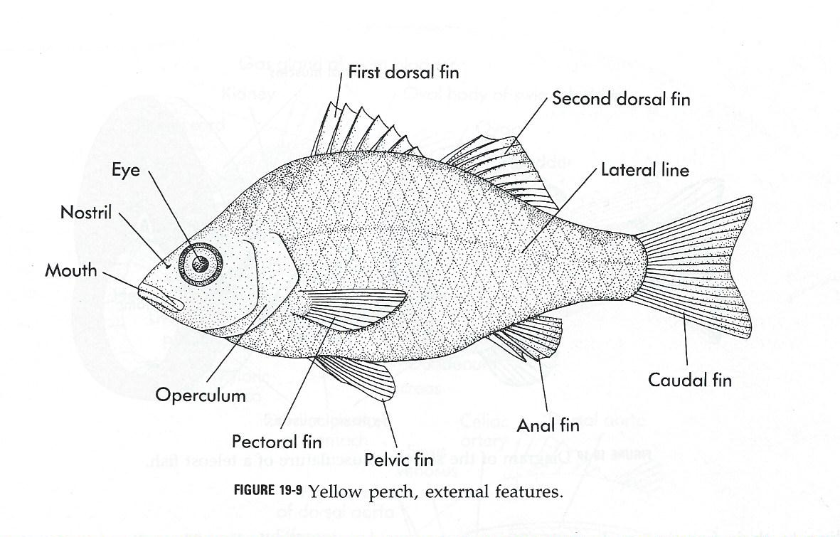

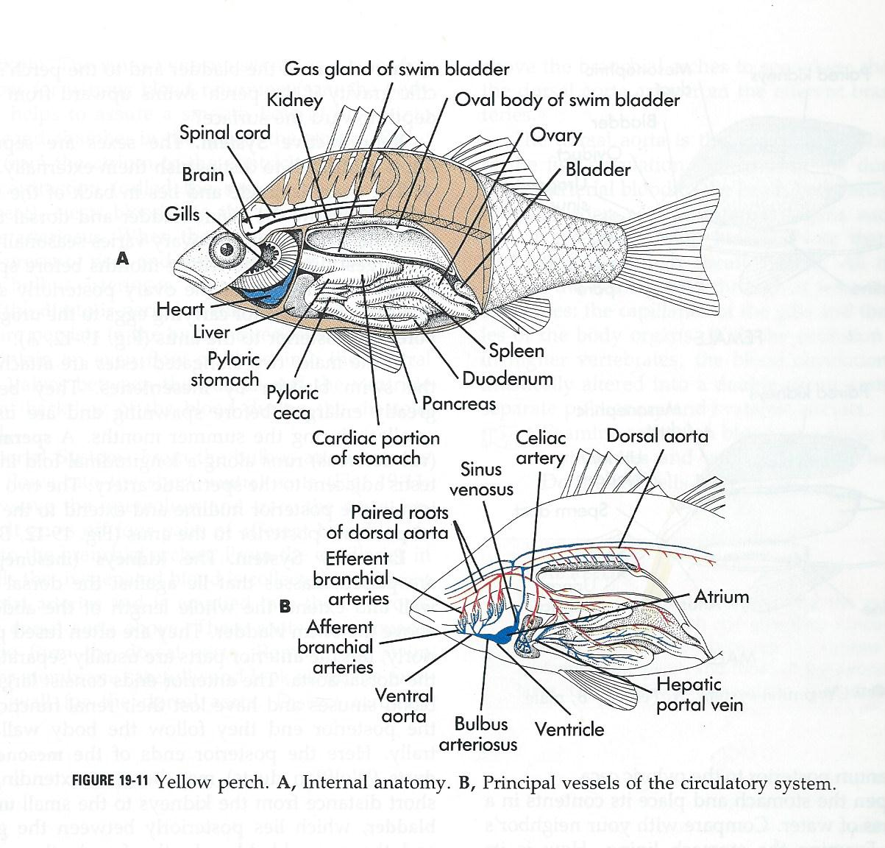

**Station 44 – CHONDRICHTHYES – EXTERNAL FEATURES**

1. What shape does it exhibit and why?
2. What type of scales do they have?
3. Note the location of the eyes. Does this animal have binocular vision? Does the animal have eyelids?
4. Note the lateral line. What is its function?
5. Be able to identify the following features: **spiracle, ampulla of Lorenzeni, claspers, the pectoral, pelvic, anal, dorsal, and caudal fins**.

**Station 45 – CHONDRICTHYES – INTERNAL FEATURES**

Know the parts and their functions listed in each section below.

|  |  |  |
| --- | --- | --- |
| **System** | **Structure** | **Function** |
| **Digestive System** | **Cardiac Stomach**  **Pyloric Stomach**  **Liver**  **Pancreas**  **Spleen**  **Ilium with spiral valve**  **Rectal Gland** |  |

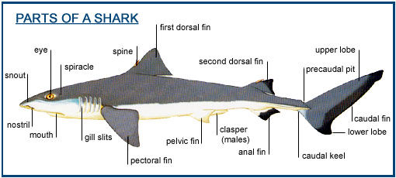

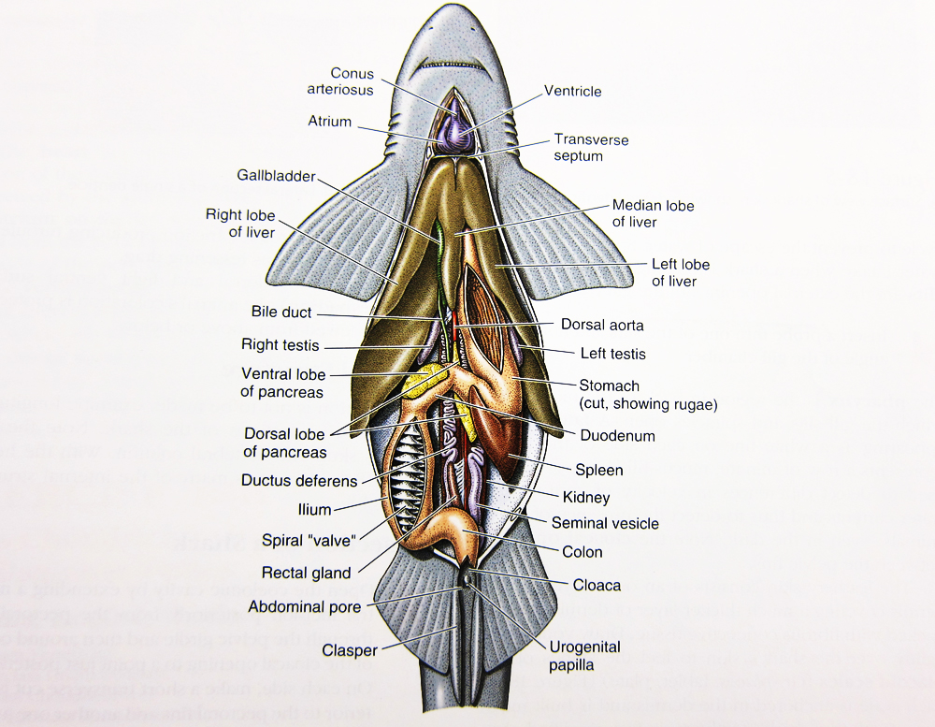

**Introduction – Phylum Tetrapods**

Although chordates vary widely in appearance, they are distinguished as a phylum by the presence of four anatomical features that appear sometime during their life time. They exhibit deuterostome development and bilateral symmetry. Chordates only comprise 5% of the animal species but may be the most commonly known phylum. They comprise of both invertebrates and vertebrates. This lab will be looking at the vertebrate animals that moved onto land. We will explore the living amphibian and reptile clades.

**Station 1 – Tetrapods**

1. What were three physical differences tetrapods evolved to accommodate their new way of life when they emerged onto land?
2. When do tetrapods appear in the fossil record? What was the name of the extinct group of lungfish that lead to the tetrapods?
3. What type of habitat did the first tetrapods evolve in?

**Station 2 – Tetrapods – General Characteristics – Oxygen Content**

1. To breath air, the lung developed from what?
2. What does a double circulatory system allow for?
3. Bony fish have 4 external nares (2 on each side) which allow water to run across the olfactory tissue. What do tetrapods have? What does this allow them to do?

**Station 3 – Tetrapods – General Characteristics – Body Density**

1. The limbs developed in shallow water. How much less buoyant is air over water? What are the homologous structures between fins and limbs?
2. In fish, the pectoral girdle is attached to the skull. What did tetrapods develop? What happed to the pelvic girdle to increase the force that can be generated by the hind legs?
3. What did the vertebrae develop to help support the spine in the absence of buoyant water? What did they also develop to protect the lungs?
4. The skull has been shortened and the snout elongated. The head separated from the body by a neck

to allow for what? Why was a second vertebrae added?

**Station 4 – Tetrapods – General Characteristics – Temperature Regulation**

1. What is the current theory of why tetrapods evolved?
2. What does an increase of 10 degrees Celsius allow for?

**Station 5 – Evolutionary History**

1. What is the name of the fossil called a “Fishapod”?

1. What fish characteristics does it have?
2. What tetrapod characteristics does it have?

**Station 6 – Class: Amphibians**

### What does the word “amphibian” mean?

1. What type of egg do they have?
2. What type of skin do they have? What does allow for?
3. When did amphibians appear in the fossil record? When did modern amphibian fossils appear?
4. Where are amphibians found?

**Station 7 – Class: Amphibians – General Characteristics**

1. What is the difference between poisonous and venomous?
2. What does poisonous mean?
3. What does venomous mean?

**Station 8 – Order: Urodela**

1. What does the word Urodela mean? What does this clade consist of?
2. How are their legs positioned?
3. What do they eat?
4. When did salamanders appear in the fossil record?
5. Where are salamanders found?

**Station 9 – California Newt**

1. How is a newt different than a salamander? What is a terrestrial juvenile called?
2. Are California Newts venomous or poisonous? What is the name of the toxin they produce? How harmful is it?
3. Where are they located?
4. What type of habitat are they found in?
5. What is their diet?

.

**Station 10 – Ensatina**

1. What is unique about their breeding locations?
2. Where are they located?
3. What type of habitat are they found in?
4. What is their diet?

**Station 11 – California Slender Salamander**

1. What type of salamander are they? How does this species breathe?
2. What are they considered due to their limited range?
3. Where are they primarily located?
4. What type of habitat can they be found in?
5. What is their diet?

**Station 12 – Order Caecilians**

1. What does the word Caecilian mean? What is the other name for this order?
2. What two characteristics are they known for?
3. When did Caecilians appear in the fossil record?
4. Where are Caecilians found?

**Station 13 – Order Anura**

1. What does the word anura mean? What does this clade consist of?
2. When does the oldest “protofrog” appear? When does the molecular clock date them?
3. Where is the greatest concentration of species diversity of anurans?

**Station 14 – Anura – General Characteristics**

1. What does the term “frog” usually refer to?
2. What does the term “toad” usually refer to?

**Station 15 – Other Anura – General Characteristics – Defense**

1. What is the toxic substance on frogs called?
2. What is the name of the poison glans on toads?
3. What do poison dart frogs secrete? Where do they get this poison? What is the term for them advertising their toxicity?

**Station 16 – Order Anura – General Characteristics – Features**

1. Where is the tongue attached? What acts like an eardrum? What is the name of the transparent membrane?
2. Note the skeleton and the preserved specimen of the frog. What are the three functions of the skull?
3. Is the skeleton as flexible as the fish skeleton? Why?
4. What is the function of the pectoral girdle?
5. What is the function of the pelvic girdle? Do frogs have ribs?

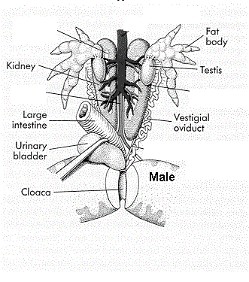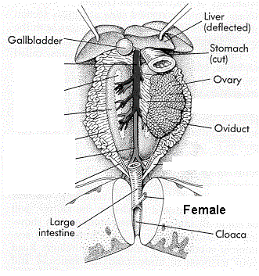

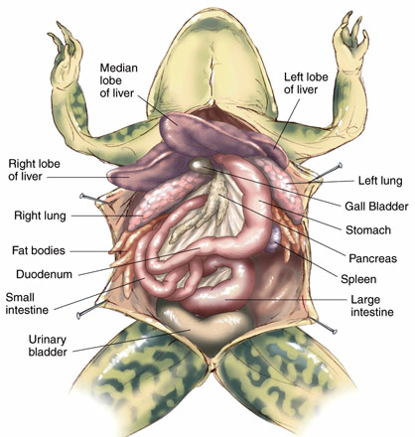

**Station 17 - CLASS AMPHIBIA – INTERNAL FEATURES**

|  |  |  |
| --- | --- | --- |
| **System** | **Structure** | **Function** |
| **Muscular System** | What is the one function of the muscles? |  |
| **Digestive System** | **Stomach**  **Intestine**  **Liver**  **Gall Bladder**  **Pancreas**  **Spleen** |  |
| **Excretory System** | **Kidneys**  **Urinary Bladder** |  |
| **Circulatory System** | **Atria (2)**  **Ventricle (1)**  Double Circuit system (whole system) |  |
| **Respiratory System** | **Lungs** |  |
| **Nervous System** | Cerebrum  Olfactory lobe  Optic lobe  Medulla Oblongata  Spinal chord |  |
| **Reproductive System** | **Ovaries or Testes** |  |

**Station 18 – Animal Sounds – Frogs** This Week you are responsible for the following animals calls:

California Tree frog

Pacific Tree Frog

California Toad

American Bullfrog

Western Spadefoot Toad

**Station 19 – Western Spadefoot Toad**

1. What type of frog are they similar to?
2. What makes them unique?
3. Where are the located?
4. What type of habitat are they found in?
5. What do they eat?

**Station 20 – Red-Spotted Toad**

1. What characteristic is used to identify them?
2. Where are the located?
3. What type of habitat are they found in?
4. What do they eat?

**Station 21 – Western Toad**

1. What characteristic is used to identify them?
2. Where are the located?
3. What type of habitat are they found in?
4. What do they eat?

**Station 22 – California Tree Frog**

1. What makes them unique?
2. Where are the located?
3. What type of habitat are they found in?
4. What do they eat?

**Station 23 – Pacific Tree Frog**

1. What makes them unique?
2. Where are the located?
3. What type of habitat are they found in?
4. What do they eat?

**Station 24 – American Bullfrog**

1. What makes them easy to identify?
2. What is it considered to be? What is the concern?
3. Where are they native to?
4. What type of habitat are they found in?
5. What do they eat?

**Station 25 – Amniotes**

1. What are amniotes? What group of amniotes are mammals found in? What group of amniotes are reptiles and birds found in?
2. When did the first amniotes appear?

**Station 26 – Amniotes – General Characteristics – Amniotic egg**

1. What does this egg allow them to do?

**Station 27 – Amniotes – General Characteristics – Skull Development**

1. What type of skull did the first reptiles have?
2. What type of skull is seen with one temporal opening? What did the opening allow? What did this line evolve into?
3. What type of skull is seen in the “True Reptiles”?

**Station 28 – Reptiles**

1. When did Reptiles originate?
2. Where are they found?

**Station 29 – Reptiles – General Characteristics**

1. What are the four Classes that make up the clade Reptiles?

**Station 30 – Class Testudines**

1. What are they characterized by and what did it develop from?
2. When did they evolve?
3. Where are they found?

**Station 31 – Class Testudines**

1. In general, what is the difference between a turtle and a tortoise?
2. From a biological perspective, what is a tortoise?

**Station 32 - Class Testudines - Turtle Skulls**

1. What type of skull are turtles believe to have now?
2. Why do they appear to be an anapsid?

**Station 33 – Class Testudines – General Characteristics**

1. What is the name of the upper part of the shell? What is the name of the lower part of the shell? What is the name of the horny scales that cover the shell?
2. What do turtles use on the beaks instead of teeth?
3. How do they use their tongues? What can’t they do that other reptiles can?
4. What are the two main turtle lineages?

**Station 34 – Green Sea Turtle**

1. Where are they located?
2. What are the three habitat types of their life stages?
3. What do they eat?

**Station 35 – Leatherback Sea Turtle**

1. How are they different than other sea turtles?
2. Where are they located?
3. What type of habitat are they found in?
4. What do they eat?

**Station 36 – Desert Tortoise**

1. Why can they live in desert areas that exceed 140 degrees Celsius?
2. Where are they located?
3. What type of habitat are they found in?
4. What do they eat?

**Station 37 – Western Pond Turtle**

1. Where are they located?
2. What type of habitat are they found in?
3. What do they eat?

**Station 38 – Red-eared Slider**

1. What are they known for?
2. Where are they originally from?
3. Why have they spread? What is it outcompeting?
4. What habitat are they found in?
5. What do they eat?

**Station 39 –Spiny Soft shelled Turtle**

1. Where do they get their name?
2. Where are they located?
3. What habitat are they found in?
4. What do they eat and what do they have to do to swallow?

**Station 40 – Mata Mata**

1. What does the Mata Mata resemble?
2. Where are they located?
3. What type of habitat are they found in?
4. How does it capture prey? Because of its mouth’s structure, what can’t they do?

**Station 41 – Class: Sphenodontia**

1. What characteristics make them different from lizards? What is unusual about their “third” eye?
2. What geological time are these “lizards” dated back to?
3. Where are they located?

**Station 42 – Class Squamata**

1. How is this class distinguished?
2. When do they appear in the fossil record? What does mitochondrial evidence suggest?
3. Where can they be found?

# Station 43 – Class: Squamata – General Characteristics

### 

1. What characteristics are found in lizards?
2. What characteristics are found in snakes?

**Station 44 – Class: Squamata - Tail Autotomy**

1. What is caudal autotomy?
2. How do lizards achieve this?

**Station 45 - Family: Agamidae**

1. What is the example for this family? What will they do when threatened?
2. How are they unique?
3. Where are they located?

**Station 46 - Family: Chameleonidae**

1. What chameleon adaptation is made to their toes?
2. What adaptations have been made to their eyes?
3. What adaptations have been made to their tongue?
4. What function does color changing provide them?
5. Where are they located?

**Station 47 - Family: Polychrotidae**

1. What is their common name? What is the name of the throat fan? What is it used for?
2. What are they often incorrectly called? Why are they called this?
3. Where are they located? Why have they become widespread?

**Station 48 - Family: Geckonidae**

1. What are they well known for?
2. What do they lack? What do they have instead? How do they keep it clean?
3. Where are they located?

**Station 49 - Family: Corytophanidae**

1. What is this lizard’s nickname and how did it get its name?
2. Where are Basilisk Lizards found?

**Station 50 - Family: Scincidae**

1. What can most skinks do to avoid predators?
2. Where are they located?
3. Where do they spend most of their time?

**Station 51 – Western Skink**

1. What is unique about Juvenile Western Skinks?
2. Where are Western Skinks located?
3. What do they eat?

**Station 52 - Family: Iguanidae**

1. What is this group of lizards main characteristic?
2. What type of lifestyle do they have?

**Station 53 – Chuckwalla**

1. How do Common Chuckwallas escape from predators?
2. Where are they located?
3. What type of habitat are they found in?
4. What do they eat?

**Station 54 – Desert Iguana**

1. What is unique about Desert Iguanas thermoregulation?
2. Where are they located?
3. What type of habitat are they found in?
4. What do they eat?

**Station 55** – **Green Iguana**

1. Why have they been introduced to other areas?
2. Why are they called a disposable pet?
3. Where are they located?
4. What type of habitat are they found in?
5. What do they eat?

**Station 56 – Marine Iguana**

1. What does their dark tones allow them to do?
2. Where are they found? Why are they unique today?
3. What do they eat?

**Station 57 - Family: Phrynosomatidae**

1. What is this family adapted for?
2. Where are they located?

**Station 58 – Zebra-tailed Lizards**

1. How will they stand at the hottest parts of the day?
2. What will they do when threatened?
3. Where are they located?
4. What habitat are they found in?
5. What do they eat?

**Station 59 – Western Fence Lizard**

1. What are these lizards also known as?
2. Where are they located
3. What habitat are they found in?
4. What do they eat?

**Station 60 – Side-blotched Lizard**

1. Where are they located?
2. What habitat are they found in?
3. What do they eat?

**Station 61 – Horned Lizard**

1. What were they called before?
2. What behavior do some Horned Lizards have for escaping from predators?
3. What do Horned Lizards eat and what adaptations do they have to allow them to do this?
4. What is rain harvesting?
5. Where are they located?
6. What habitat are they found in?
7. What do they eat?

**Station 62 - Family: Anguidae – The Southern Alligator Lizard**

1. Where are they located?
2. What habitat are they found in?
3. What do they eat?

**Station 63 - Family: Anniellidae - California Legless Lizard**

1. How can you tell they are not snakes?
2. How is their basking different than other lizards?
3. What habitat are they found in?
4. What do they eat?

# Station 64 – Family: Crotaphytidae - Blunt-nosed Leopard Lizard

1. Why is this species disappearing?
2. Where are they located?
3. What do they eat?

# Station 65 – Family: Teiidae - Western Whiptail Lizard

1. What sexual behavior are they known for?
2. Where are they located?
3. What habitat are they found in?
4. What do they eat?

# Station 66 – Family: Helodermatidae

1. How are their venom glands different then snakes? What do they lack?
2. What is the venom used for? How do they get it into their victims?
3. What are the two venomous lizards in this family?
4. What is the other venomous lizard?

**Station 67 - Class: Squamata (Snakes)**

### What do these organisms usually lack?

### What adaptation is seen in their skulls?

### What did they probably evolve from and when

### Where are they located?

**Station 68 - Snakes – General Characteristics**

1. What is the function of the Jacobsen’s organ?
2. What is the function of the Loreal Pits?

**Station 69 – Family Elapsidae**

1. What does this family include?
2. What are they characterized by?
3. What type of toxins do they have?
4. Where are they located?
5. How do they hunt?

**Station 70 – King Cobra**

1. What is this species known for?
2. A typical bite can kill how many people?
3. What does it do when it is confronted?
4. Where are they located?
5. What habitat are they found in?
6. What do they eat?

**Station 71 – Taipan**

1. What is this species known for?
2. A typical bite can kill how many people?
3. Where are they located?
4. What habitat are they found in?
5. What do they eat?

**Station 72 – Sea Snakes**

1. What is this species known for?
2. How are they adapted for a life at sea?
3. Where are they located?
4. What habitat are they found in?
5. What do they eat?

**Station 73 - Family: Boidae**

1. Are they venomous?
2. What large snake is included in this family?
3. What makes them unique?
4. Where are they located?
5. What do they eat?

**Station 74 – Rosy Boa**

1. What do they do when they are disturbed?
2. Where are they located?
3. What habitat are they found in?
4. What do they eat?

**Station 75 – Green Anaconda**

1. What are they known for?
2. Where are they located?
3. What habitat are they found in?
4. What do they eat?

**Station 76 - Family: Pythonidae**

1. Are they venomous?
2. What large snake is included in this family?
3. How do they differ from Boas?
4. Where are they located?
5. What do they eat?

**Station 77 – Rock Python**

1. What is it known for?
2. Where are they located?
3. What habitat are they found in?
4. What do they eat?

**Station 78 – Family: Colubridae**

1. Are they venomous?
2. What makes them unique?
3. When did they show in the fossil record?
4. Where are they found?

**Station 79- Ring-necked Snake**

1. Are these snakes venomous?
2. What are these snakes known for?
3. Where are they located?
4. What habitat are they found in?
5. What do they eat?

**Station 80 – Coachwhips**

1. What are these snakes known for?
2. Where are they located?
3. What habitat are they found in?
4. What do they eat?

**Station 81 – Western Shovel-nosed Snake**

1. What are these snakes known for?
2. Where are they located?
3. What habitat are they found in?
4. What do they eat?

**Station 82 – King Snake**

1. Why are these snakes called King snakes?
2. Where are they located?
3. What habitat are they found in?
4. What do they eat?

# Station 83 – Gopher Snake

1. What are these snakes mistaken for?
2. How can you tell them apart?
3. Where are they located?
4. What habitat are they found in?
5. What do they eat?

# Station 84 – Family: Viperidae

1. What type of fangs do they have? How do they “bite”?
2. Which type of snake is more dangerous?
3. When do they first appear in the fossil record?
4. Where are the located?
5. What two categories is the venom placed in?

**Station 85 – Western Diamondback**

1. What makes them unique?
2. Where are they located?
3. What type of habitat are they found in?
4. What do they eat?

**Station 86 – Red Diamond Rattlesnake**

1. What makes them unique?
2. Where are they located?
3. What type of habitat are they found in?
4. What do they eat?

**Station 87 – Speckled Rattlesnake**

1. What makes them unique?
2. Where are they located?
3. What type of habitat are they found in?
4. What do they eat?

**Station 88 – Western Rattlesnake**

1. What makes them unique?
2. Where are they located?
3. What type of habitat are they found in?
4. What do they eat?

**Station 89 – Sidewinder**

1. What makes them unique?
2. Where are they located?
3. What type of habitat are they found in?
4. What do they eat?

**Station 90 – Mohave Rattlesnake**

1. What makes them unique?
2. Where are they located?
3. What type of habitat are they found in?
4. What do they eat?

# Station 91 – Class: Crocodilia

1. What are the four groups of crocodilia?
2. What are they closely related to?
3. When do they appear in the fossil record?
4. Where are they located?

**Station 92 – Class: Crocodilia**

**Be able to identify the four types – Know how they are told apart**

1.

2.

3.

4.

**Station 93 – Animal Sounds – Reptile -** This Week you are also responsible for the following animal’s calls:

Rattlesnake Alligator Baby Alligator