Homework: Chapter 2
20 points.
Earth-Sun Relations, p.41 – 47.
- At the June Solstice, what portion of the Earth’s surface receives the sun’s rays for the entire 24 hours? What portion of the Earth’s surface does not receive the sun’s rays for the entire 24 hours? Explain why.

- Explain the same distribution of the sun’s rays as in question #1, but on the December Solstice.

- On what dates are the lengths of day and night exactly the same for all latitudes. Explain why.

- How many times a year does the sun appear vertically (90°angle) overhead at the following latitudes?
- Tropic of Cancer_______________________________

- The Equator___________________________________

- 10°N _______________________________________

- Mazatlan, Mexico________________________________

- Cape Town, South Africa______________________________

- Moscow, Russia_____________________________________

- What does this variability in direct sunlight receipt indicate about seasonal change
- Near the Equator b.Toward the Poles

- What does the midnight sun refer to, where would you go to see it, and when?

- If the Earth’s axis was not inclined at an angle of 23 1/2°, how would the distribution of solar radiation around the Earth differ than now?

8. Calculate the angle of the sun’s rays at noon for the following:

Your location Declination Latitude NSA
a. Equator 0°

b. 25°N 0°

c. 5°N March 15th

d. 70°N January 20th

9.
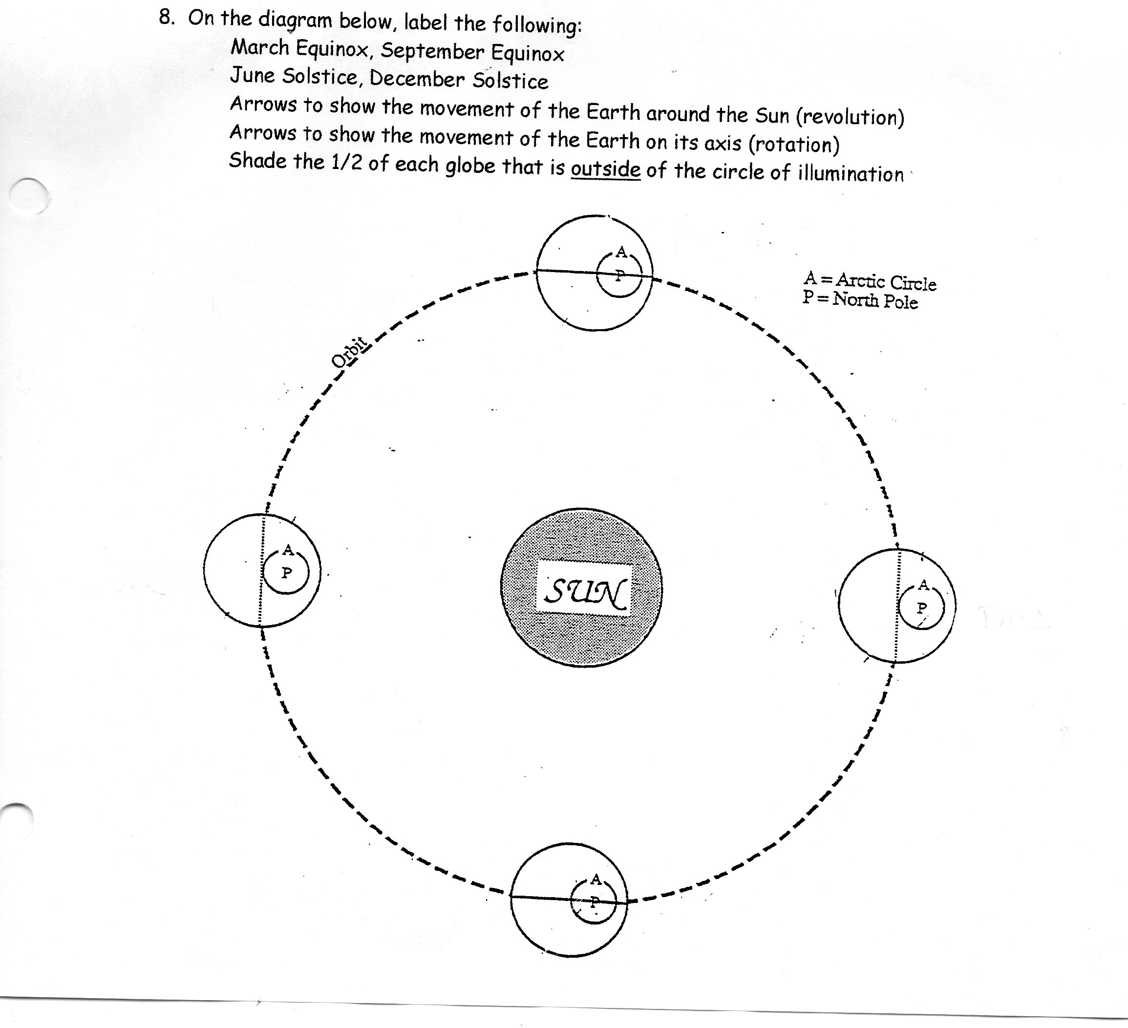

10. Explain the greenhouse effect in the Earth’s energy output.

