Homework: Chapter 6
20 points

Midlatitude Cyclone and Fronts, p. 165-170.
Refer to the midlatitude cyclone diagramed below for the following questions:

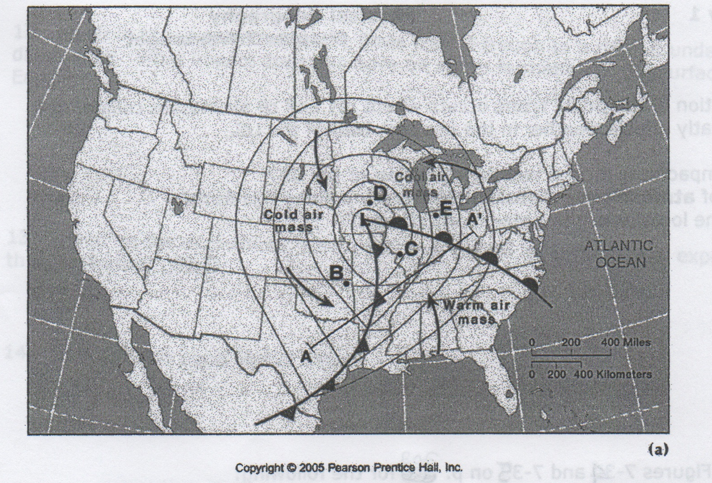
Key: City B = Tulsa, Oklahoma
City C = St. Louis, Missouri
City D = Des Moines, Iowa
City E = Detroit, Michigan

1. Which city (of the four listed) is receiving the greatest total rainfall for the next day and a half? Explain your answer.

2. What city is most likely going to receive thunderstorms in the next 12 hours? Why?

3. Which of the following would describe the expected weather for Detroit over the next 12 hours:
a. thunderstorms followed by cool weather & low humidity
b. steady rainfall followed by warmer weather & high humidity
c. clear skies followed by rain showers and falling temperatures
d. severe weather, such as thunderstorms, followed by clearing and cooler temperatures

4. The area experiencing the heaviest (most intense) rainfall currently is:
a. Central Missouri
b. West Texas
c. Washington D.C.
d. Michigan

5. What part of the United States would expect to be experiencing an anticyclone? Why?

6. Where are skies the clearest: Texas, Georgia, Wyoming or North Carolina? Why?

7. You are experiencing an occluded front at your location.

a.) Are there any warm conditions? Why or why not?

b.) Is there any rainfall? If so, describe its intensity and duration.

Thunderstorms and Tornadoes, p. 181-186.
Refer to Figure 6.23 p. 186 to answer the following questions.

8. Why do 90% of the world’s tornadoes occur in the U.S.?

9. In what area of the U.S. do these tornadoes occur and why?

10. What time of year are tornadoes most likely to occur and why?

