**Education Planning Workshop  
Purpose: To develop a first semester education plan based on the student’s declared program of study. The program of study is defined as the educational goal; an occupational certificate, associate degree, or transfer toward a bachelor degree, along with the student’s declared major. The major is defined as the focused area of study (academic specialty) leading to a specific career goal, or a specific area of academic interest, which may lead to further education. Additionally, the plan shall take into consideration assessment for placement results, basic skills, possible prerequisites, interests, skills, and unit load. If the student is undeclared or undecided on specific program of study, course selection may be determined by a possible general career interest.**

1. What classes do I take?
2. It depends. What is your declared program of study?

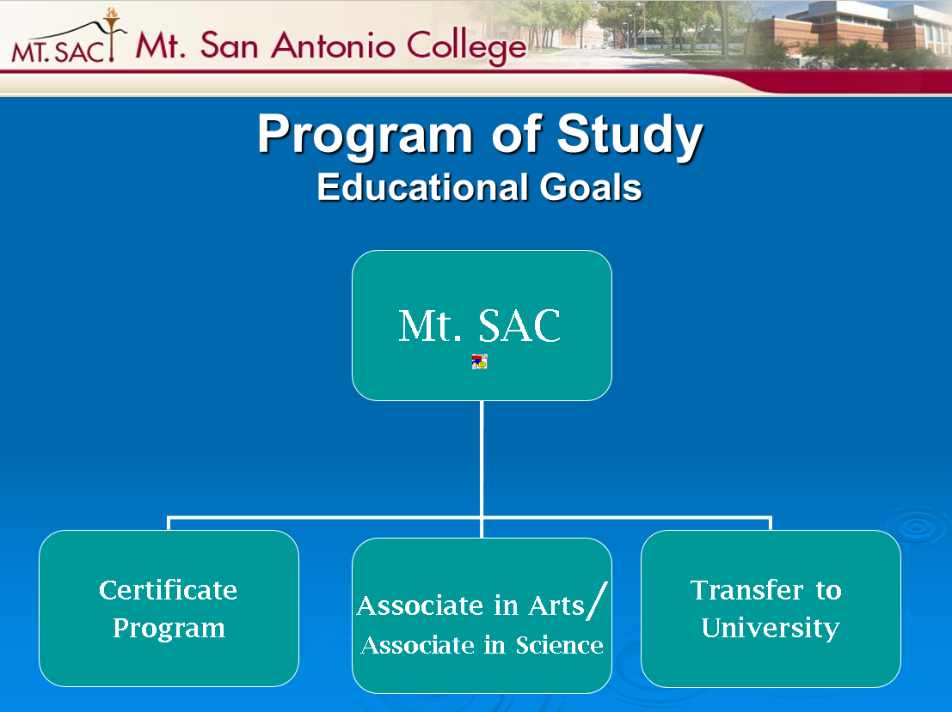

1. Let’s review your Mountie Academic Plan (MAP) Worksheet.

[[](http://www.mtsac.edu/map/)](http://www.mtsac.edu/map/)

1. What are your placement test results? Where do you start?

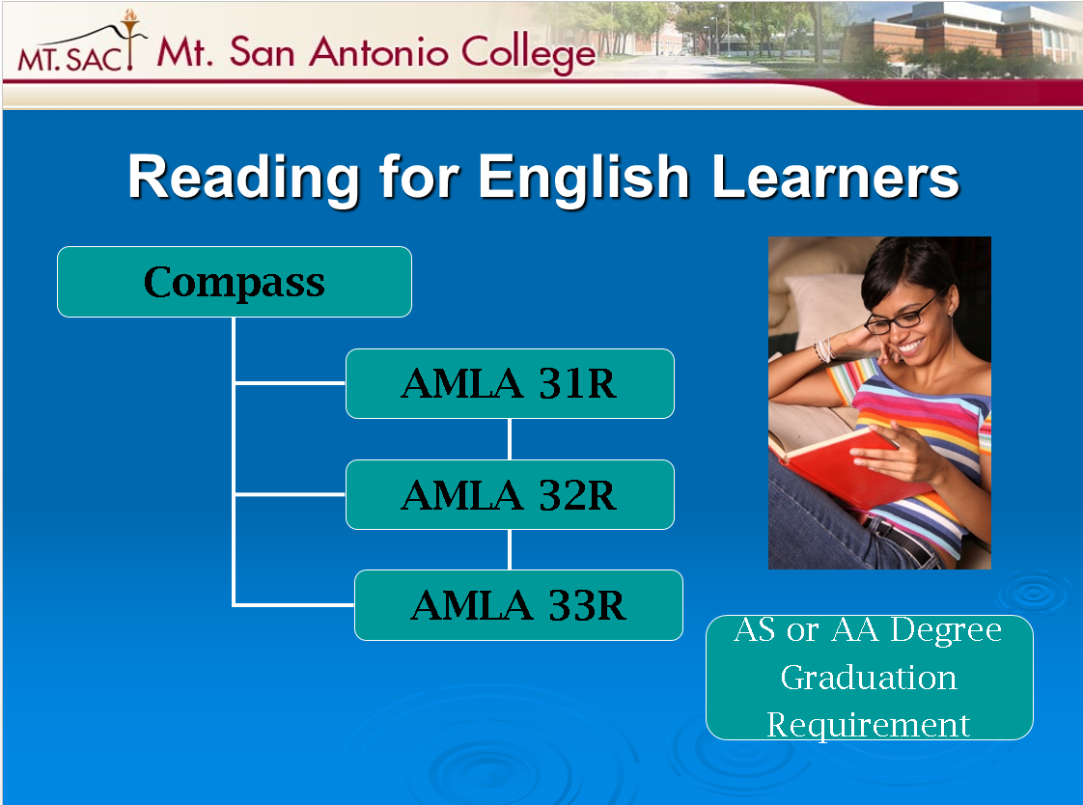 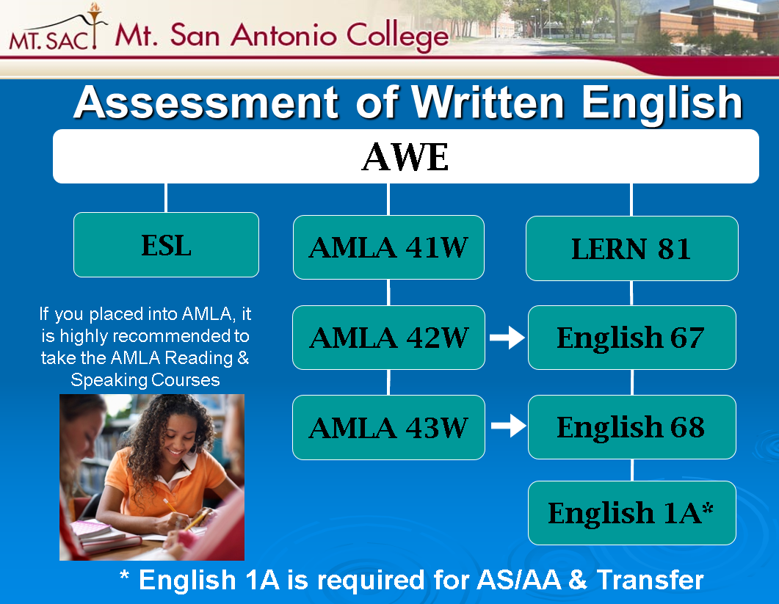

##### [**Assessment Center**](http://www.mtsac.edu/assessment/)

1. Are you planning to be a full-time or part-time student?
2. Full-time is at minimum 12 units in a semester (4 units in an intersession).
3. Part-time is less than 12 units in a semester (less than 4 units in an intersession).
4. Consider 9 units in a semester as ¾ time.
5. Consider 6 units in a semester as ½ time.
6. What is a prerequisite (co-requisite, advisory)? - address basic skills students.  
   [**Prerequisites, Corequisites, and Advisories &** **Challenging Prerequisites and Corequisites**](http://catalog.mtsac.edu/student-success-support-program/prerequisites-corequisites-advisories/#challengingprerequisitesandcorequisites)

[Astronomy Prereqs and Coreqs](http://catalog.mtsac.edu/coursesaz/astr/)  
[CISN 11 Advisory Prereq](http://catalog.mtsac.edu/coursesaz/cisn/)

1. What are educational goals?
2. [Occupational Certificate](http://catalog.mtsac.edu/programs-leading-to-a-certificate/)
3. [Associate Degree](http://catalog.mtsac.edu/programs-leading-to-associate-degree/)
4. [Transfer](http://www.mtsac.edu/transfer/websites.html)
5. [What are Guided Pathways? – Templates – transfer temp. solution](http://catalog.mtsac.edu/areas-interest/)
6. What if I am undeclared or undecided?

[Counseling Services](http://www.mtsac.edu/_sandbox/matt_b/counseling_mockup/)

1. Let’s select courses (things to consider).
2. Interest
3. Availability
4. Eligibility
5. What about alternatives?   
   GE Patterns: [Associate Degree](http://catalog.mtsac.edu/programs-leading-to-associate-degree/#requirementsforaaandasdegrees201617text) [CSU](http://www.mtsac.edu/transfer/ge_sheets/CSUGE.pdf) [IGETC](http://www.mtsac.edu/transfer/ge_sheets/IGETC.pdf)  
    [Schedule of Courses](https://prodssb.mtsac.edu/prod/pw_sigsched.p_Search) [Catalog](http://www.mtsac.edu/catalog/)
6. Next steps.
7. [Definition of Terms](http://catalog.mtsac.edu/course-descriptions/)

<http://www.goodreads.com/author/show/4491185.Steve_Maraboli>

“If you don’t know exactly where you’re going, how will you know when you get there?”    
― [**Steve Maraboli**](http://www.goodreads.com/author/show/4491185.Steve_Maraboli), [**Life, the Truth, and Being Free**](http://www.goodreads.com/work/quotes/14708444)

“A clear vision, backed by definite plans, gives you a tremendous feeling of confidence and personal power.”    
― [**Brian Tracy**](http://www.goodreads.com/author/show/22033.Brian_Tracy), [**The Gift of Self-Confidence**](http://www.goodreads.com/work/quotes/49592662)

<http://www.studentpathway.com/demos.html>

<http://cms.cerritos.edu/counseling/tune-up/default.htm>

<http://www.cynosurenewmedia.com/demos/ClarkOA/clark.asp>