Self Direction Name:______________________

A Rapidly-Changing World

Point of the Assignment: 1) To recognize how much the world is changing in our lifetime. 2) To accept the need to adapt to this changing world if you want to maintain your employability. 3) To give you coping skills for living in a rapidly-changing world.

Today’s world can be pictured by the following graphs, which illustrate the rate at which new information, change and complexity have been impacting the world since about 1940 (through the advancement of technology) : (Miller, 2004)
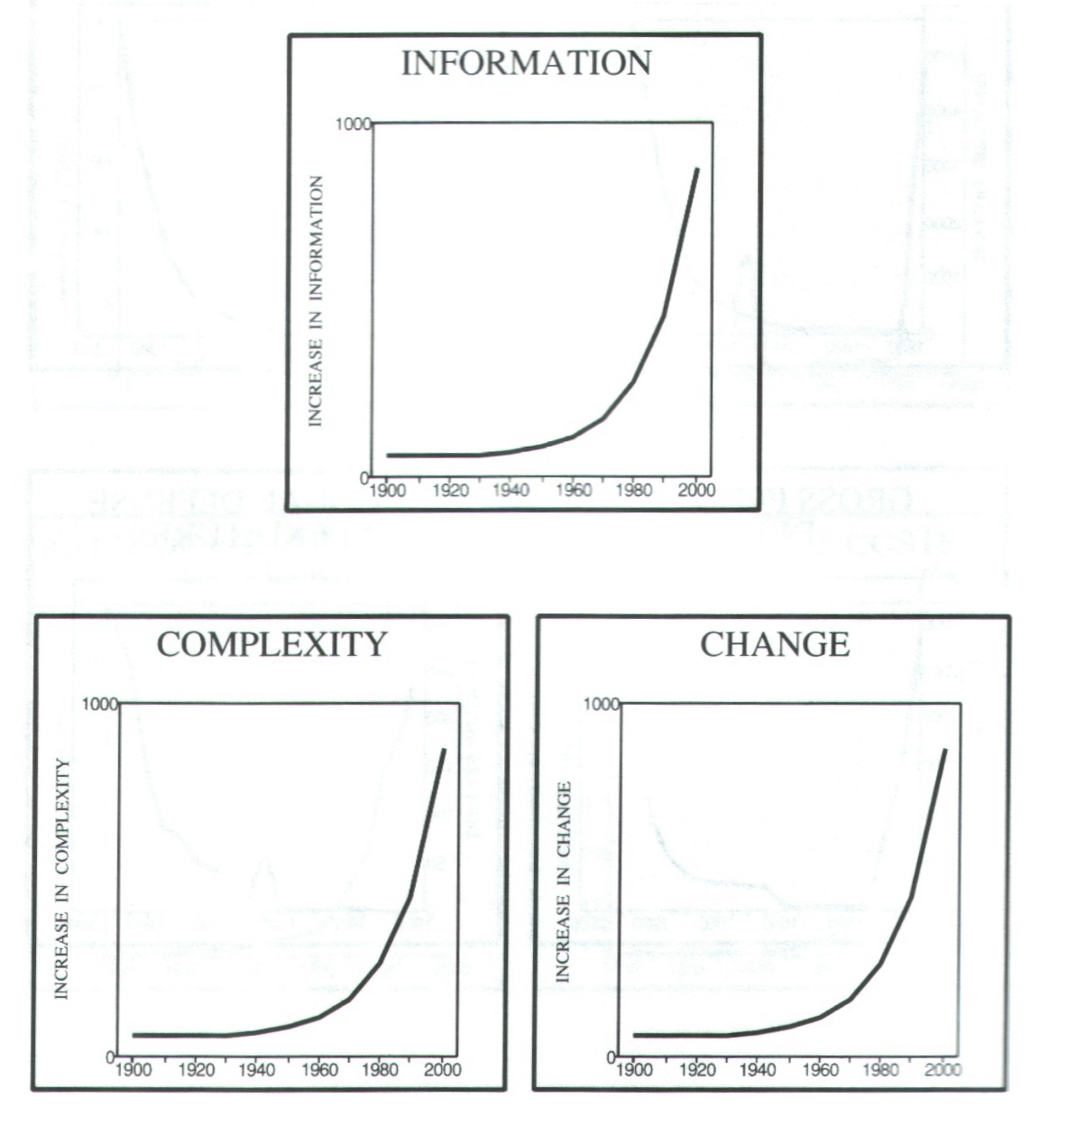

Coping With Constant Change

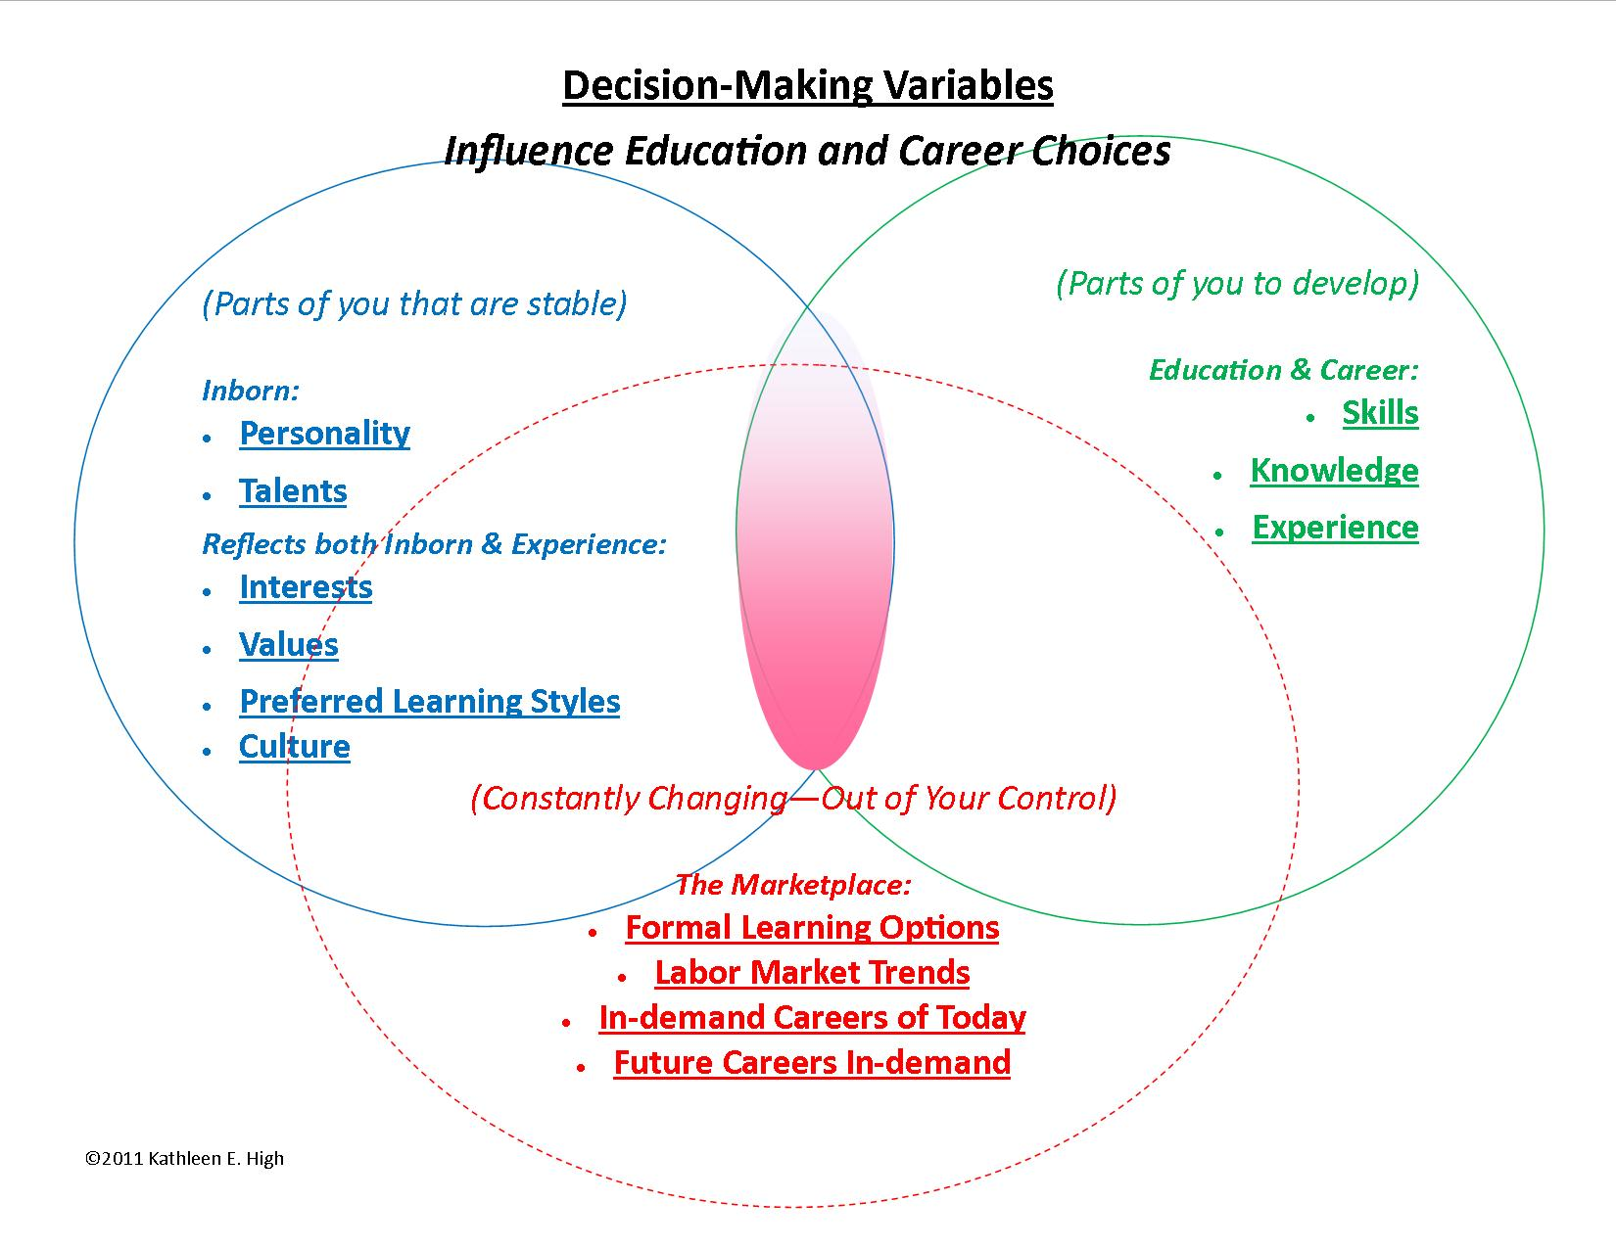

(Image: Variables that affect education and career decisions. See end of document for a larger copy.)

Many people may find that anticipating living in a world where there seems to be nothing on which they can depend can be too frightening or anxiety-producing to face. The good news is that there is an answer as to how to live in such a world. – It requires that you develop certain coping skills:
- Recognize the world in which you live. Ignoring it won’t make go away.
- Develop good “life skills” such as self-discipline, self-motivation, knowing priorities, healthy boundaries, stress management, money management (saving and budgeting) and coping skills, ability to focus on a task/goal, relationship management, respect for authority, etc. A lack of these basic life skills will interfere with you achieving the rest of these things.
- Recognize a need for NEW life skills to survive in a world of constant change. Just a few decades ago (i.e. the world the Baby Boomers grew up in) the world was rather stable and required a certain set of life skills in order to succeed in life. Life skills such as hard work, persistence, willingness to earn what you get in life, patience, independence, stability and following “the rules” could normally lead to a prosperous life. However, living in a world that is changing so fast that the future literally cannot be predicted requires a different set of life skills to survive: Skills such as adaptability, interdependence, resourcefulness, tolerance for diversity, and developing transferrable skills. In addition, a person also needs to learn how to recognize “The Hidden Rules” present in any given situation. Discernment is also important: He or she also needs have an ability to discern which set of the “right rules” are appropriate in a given situation. (I.e. Behavior X may be appropriate at home, but it is NOT appropriate at work.)
- Engage in continual self-awareness where you continuously recognize who you are, how you are gifted, how you are not gifted, your interests and values, and what kinds of careers/jobs will suit you and what kinds will not. It also involves recognizing how we change and grow and adapt over time.
- Accept responsibility for your own career development (career self-direction).
  - Do not expect an employer to provide eternal job security. (That institution may not be around when you are ready to retire.)
  - Continuously maintain your employability:
    - Develop good job hunting skills (maintain an updated resume and network, know and where to find jobs in your profession, have good interviewing skills, know where to find “survival jobs”, etc.)
- Be prepared to engage in lifelong learning (learning throughout your life).
  - Understand the difference between transferable and technical skills”
  - “Develop strong transferable skills”
    - Critical thinking (information gathering, creative problem solving, and decision making), Communication (verbal and written), and Interpersonal skills (dealing with people – especially people who are different from you).
  - “Engage in life-long learning of technical skills”
    - (Equipment and operational processes – including computer skills)
  - Know the best ways for you to educate yourself (formal education vs. self-taught).
  - Keep up with technological changes in your profession.
  - Recognize when changes in the economy/society/technology/job processes will require a paradigm shift about how to get the work done.
- Be prepared to hold multiple careers throughout your lifetime as the economy-driven needs will affect your job marketability.
- Recognize that your generation will impact your worldview and how you will likely respond to this. Therefore, it will also likely impact your potential challenges. For example:
    - If you were born before approximately 1960, you are more likely to resist keeping up with advances in technology because you had likely originally learned to do things without computers, and therefore do not feel you need to learn to adapt to them.
    - If you were born before approximately 1965, you will be more likely to possess good basic math, reading and writing skills than students of younger generations because you would have been educated during an era that emphasized teaching and reinforcing fundamental skills in elementary school.
    - If you were born before approximately 1970: You will likely recognize the changes and its impact on the world, but may not recognize you need to respond to it (adaptability). You were likely told growing up that, “You just need to get a good job and you will be set for life.” Therefore you will likely want to hold on to the obsolete assumption that permanent job security is still attainable in today’s world.
    - If you were born before approximately 1970, you will be more likely to hold a Modernist world view (a belief in absolute truth).
    - If you were born after approximately 1970, you will be more likely to hold a Post-Modernist world view (a belief that there is no such thing as absolutes).
    - If you were born after approximately 1970: You may have been prepared for how to respond to these changes (adaptability), but may not register the severity of impact these changes will have on your future life due to your lack of life experience. You were more likely told “In today’s world, you will need a college education in order to survive financially, and you should expect to have many different careers in your life.”
    - If you were born after approximately 1980, you are probably much more technologically savvy than your parents because you grew up having technology a part of everyday life.
    - If you were born before approximately 1980, you will be more likely able to have the necessary attention span and discipline to sit through a lecture-style teaching method because you likely grew up in a slower-paced and more stable environment than individuals born after you.⁵
    - If you were born after approximately after 1980, you will likely have a harder time sitting through a lecture-style teaching method because you likely grew up in a faster-paced, multi-media, and highly-stimulated environment, and thus have a shorter attention span.

Personal Application:
You may wonder why this subject has been brought up in this class. There are two primary reasons:
- These changes are worldwide and universal
2) These changes are directly affecting the world where you will be trying to develop your job marketability.

Therefore you need to recognize and accept the world in which you live, and learn how to adapt to it.
Your Personal Awareness
- Note the image “Decision-Making Variables” on Page 2.
  - According to this chart, which variables are stable and should therefore be the foundation of your decision making?
_____________________________________________________________________
_____________________________________________________________________
  - Which variables are too unpredictable to base decisions on?
_____________________________________________________________________
_____________________________________________________________________
  - Which variables can you control?
_____________________________________________________________________
_____________________________________________________________________
- Of all the examples of a changing world given (from the videos), which are easy for you to understand? Why?
___________________________________________________________________________
___________________________________________________________________________
- Of all the examples of a changing world given (from the videos), are any of them difficult to understand? Why?
___________________________________________________________________________
___________________________________________________________________________
- Give a personal example from your own life of how advances in technology are affecting your (or someone you know) ability to get and/or keep a job.
___________________________________________________________________________
___________________________________________________________________________
- How long has it been since you left high school? Is the world in which you live now very different from when you left high school? If so, describe?
___________________________________________________________________________
___________________________________________________________________________
- Interview someone who is of a different generation from you (at least 20 years older or younger than you), and ask them to answer Question #4. List their name, age, and relationship to you. What did they say?
___________________________________________________________________________
___________________________________________________________________________
- What did you discover from their response? What are some of the differences between yourself and this person who is of a different generation?
___________________________________________________________________________
___________________________________________________________________________
- People are likely to have mixed reactions to the idea of knowing they are trying to maintain job marketability in a world that cannot be predicted. How do you personally feel about this?
___________________________________________________________________________
___________________________________________________________________________
- On the last page of this document, you will find a graph. Mark the following significant events in your life (including those in the future): Birth, year graduate high school, anticipate college graduation, marriage, birth of children, buy a home, anticipate retirement, and anticipate death. Once you have done that, compare those milestones to the line which indicates the rate of change and write down what you see.
___________________________________________________________________________
___________________________________________________________________________

Developing Your Personal Response
Look at the section on Page 2-4, titled: “Coping With Constant Change.”
- Which of the coping strategies listed do you feel are fairly easy for you to accept and adopt? Why?
_____________________________________________________________________
_____________________________________________________________________
- Which of those coping strategies listed do you feel will be a challenge for you to accept and adopt? Why?
_____________________________________________________________________
_____________________________________________________________________
- What can do to help yourself to prepare for living in a rapidly-changing world?
_____________________________________________________________________
_____________________________________________________________________
Test your understanding:
What is the main point of this assignment?
______________________________________________________________________________
______________________________________________________________________________
Why were you expected to do this exercise?
______________________________________________________________________________
______________________________________________________________________________
What type of person would need to do this exercise?
______________________________________________________________________________
______________________________________________________________________________
How well do you fit the profile of the person for whom this assignment was created?
______________________________________________________________________________
______________________________________________________________________________
Reflection: (Write down your response after completing this assignment.)
______________________________________________________________________________
______________________________________________________________________________

Miller, K.A., (2004). Surviving information overload. Grand Rapids: Zondervan.
(2005). American Generations: Who they are and how they live. (5th ed.). In N. S. Publications, American Generations (5th ed.). Ithaca, New York: New Strategist Publications.

